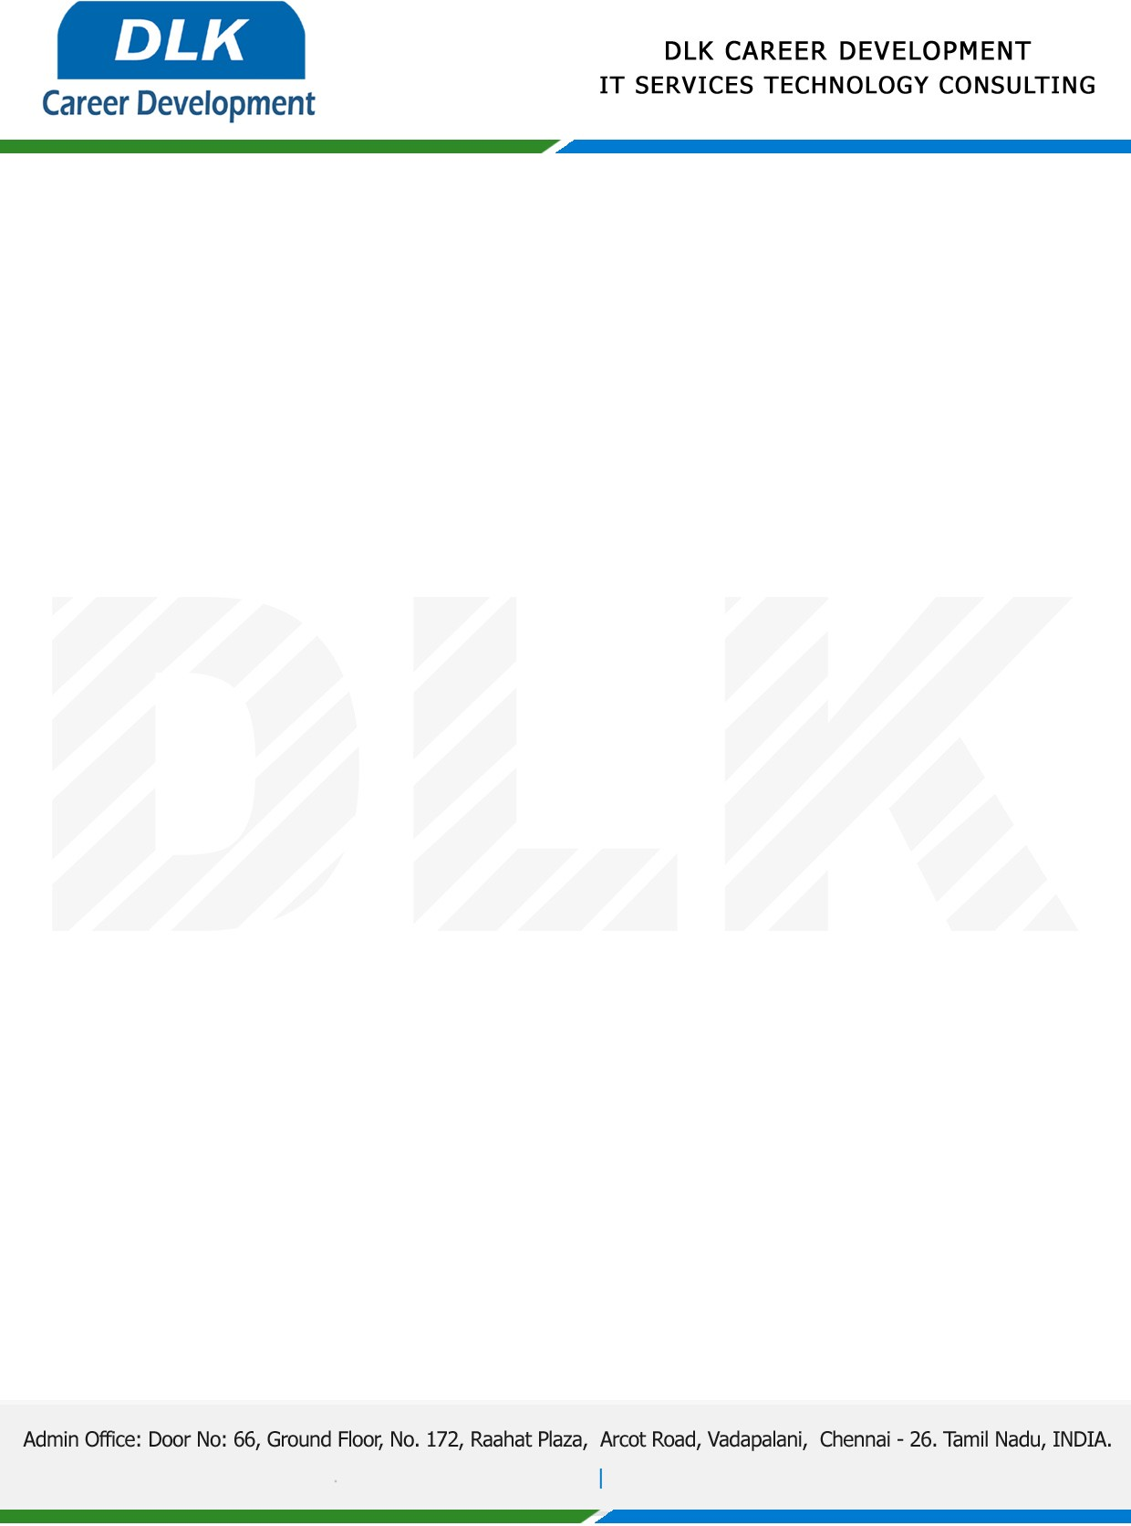

**Date: 02/ March /2023**

**SUB: PROJECT COMPLETION CERTIFICATE**

This is to certify that **MS KOWSALYA S (REG NO: 832100392) MSC- Computer Science,** final year student **Valliammal College for Women, Chennai** has Successfully Completed the Project Work under the domain of “**Java”** in our organization during the Period **(January 2023 to May 2023).**

**Topic:** Modern aspects of controlling the competitiveness of transport complex based on innovative system.

We appreciate your interest in **DLK CAREER DEVELOPMENT**

**“Best Wishes for Your Future Endeavors “**

